Project 1 Doc.

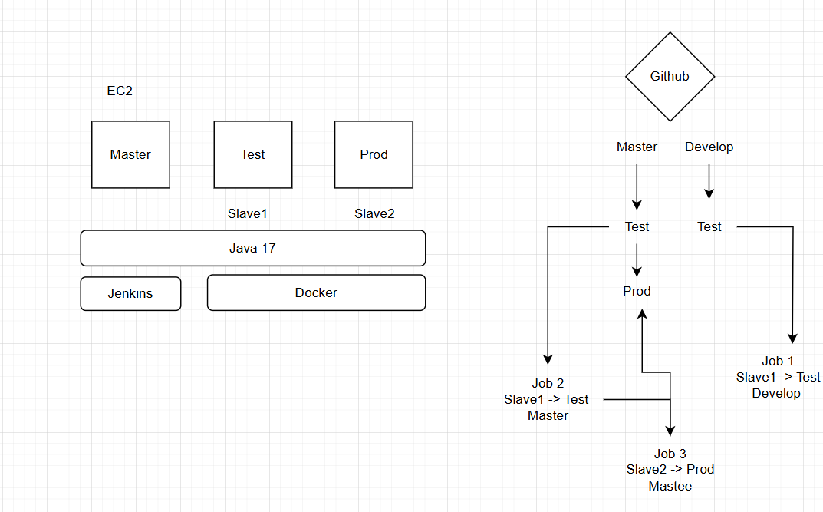

Ansible Instlln

<https://docs.ansible.com/ansible/latest/installation_guide/installation_distros.html>

Playbook

---

- name: tasks fr master

hosts: localhost

become: true

tasks:

- name: task execution

script: master.sh

- name: tasks fr slave

hosts: Slave

become: true

tasks:

- name: task execution

script: slave.sh

[master.sh](http://master.sh)

sudo apt update

sudo apt install openjdk-17-jre -y

sudo wget -O /usr/share/keyrings/jenkins-keyring.asc \

https://pkg.jenkins.io/debian-stable/jenkins.io-2023.key

echo "deb [signed-by=/usr/share/keyrings/jenkins-keyring.asc]" \

https://pkg.jenkins.io/debian-stable binary/ | sudo tee \

/etc/apt/sources.list.d/jenkins.list > /dev/null

sudo apt-get update

sudo apt-get install jenkins -y

[slave.sh](http://slave.sh)

sudo apt update

sudo apt install openjdk-17-jre -y

sudo apt install docker.io -y

Dockerfile

FROM ubuntu

RUN apt update

RUN apt install apache2 -y

ADD . /var/www/html/

ENTRYPOINT apachectl -D FOREGROUND

Master vm

1 sudo apt update

2 $ sudo apt update

3 $ sudo apt install software-properties-common

4 $ sudo add-apt-repository --yes --update ppa:ansible/ansible

5 $ sudo apt install ansible

6 sudo apt update

7 sudo apt install software-properties-common

8 sudo add-apt-repository --yes --update ppa:ansible/ansible

9 sudo apt install ansible -y

10 ssh-keygen

11 cd .ssh/

12 ld

13 ls

14 sudo cat id_rsa.pub

15 cd

16 cd /etc/ansible/

17 ls

18 sudo nano hosts

19 ansible -m ping all

20 sudo nano play.yaml

21 sudo nano master.sh

22 sudo nano slave.sh

23 ansible-playbook play.yaml --syntax-check

24 ansible-playbook play.yaml --check

25 ansible-playbook play.yaml

26 sudo nano hosts

27 sudo nano play.yaml

28 ansible-playbook play.yaml

29 cd

30 jenkins --version

31 cd

32 ls

33 cd /etc/ansible/

34 ls

35 sudo cat play.yaml

36 sudo cat master.sh

37 sudo cat slave.sh

38 sudo cat /var/lib/jenkins/secrets/initialAdminPassword

39 cd

40 history

Test vm

2 cd .ssh/

3 ls

4 sudo nano authorized_keys

5 docker --version

6 ls

7 cd

8 ls

9 cd jenkins/

10 ls

11 cd workspace/

12 ls

13 cd

14 history

Prod vm

2 cd .ssh/

3 sudo nano authorized_keys

4 java --verison

5 java --version

6 ls

7 cd

8 ls

9 cd jenkins/

10 ls

11 cd

12 history